**Global Energy Trends: A Comprehensive Analysis of Key Regions and Generation Modes using Power BI**

**Introduction**

Energy plays a vital role in various aspects of modern life, and its importance is expected to increase further as electric vehicles and heat pumps become more prevalent for transportation and heating. Although power generation currently accounts for a significant portion of global CO2 emissions, it is also leading the way in transitioning to net-zero emissions by rapidly adopting renewable energy sources like solar and wind power.

The energy landscape is undergoing a substantial transformation with a strong focus on sustainability and effectiveness. In this context, incorporating renewable energy sources and optimizing energy usage are crucial. Enhancing energy efficiency and integrating renewable generation are key elements in moving towards a more sustainable energy future. Utilizing data analysis techniques within the energy sector holds considerable promise for achieving these goals.

**Scenario 1:**

Smart Grid Implementation in Urban Areas:

 In a bustling urban city, the local government has embarked on a project to upgrade its energy infrastructure to meet the increasing demands sustainably. They have implemented a smart grid system that integrates renewable energy sources like solar and wind power into the existing grid. This system allows for more efficient distribution of electricity, minimizing energy loss during transmission. Moreover, smart meters installed in households provide real-time data on energy consumption, enabling residents to monitor and adjust their usage patterns. As a result, the city experiences reduced reliance on fossil fuels, lower CO2 emissions, and increased resilience to power outages.

**Scenario 2:**

Industrial Energy Management in Manufacturing Plants: A large manufacturing plant recognizes the importance of optimizing energy usage to enhance its sustainability and cost-effectiveness. Leveraging data analysis techniques, the plant implements an advanced energy management system that monitors energy consumption across various processes in real-time. Through predictive analytics, the system identifies areas of inefficiency and suggests optimization strategies, such as scheduling production during off-peak hours or upgrading equipment to more energy-efficient models. Additionally, the plant integrates renewable energy sources like rooftop solar panels to offset its reliance on grid electricity further. This initiative not only reduces the plant's carbon footprint but also leads to substantial cost savings over time.

**scenario 3:**

 Rural Electrification Project in Developing Countries

In a remote rural community in a developing country, access to reliable electricity has been a longstanding challenge. To address this issue sustainably, a non-profit organization initiated a rural electrification project focused on utilizing renewable energy sources. They install solar microgrids to power homes, schools, and community centers, providing access to clean and affordable electricity for the first time. Data analytics are employed to optimize the operation of these microgrids, ensuring efficient energy distribution and minimal wastage. As a result, the community experiences significant improvements in living standards, with enhanced educational opportunities, better healthcare facilities, and economic empowerment through small-scale enterprises powered by electricity. This project serves as a model for sustainable development in similar rural areas worldwide, demonstrating the transformative potential of renewable energy and data-driven solutions.

**Technical Architecture:**

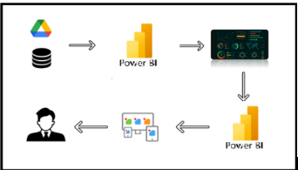

**Project Flow**

The activities listed below must be completed:

1. Data Collection

* Collect the dataset
* Connect Data to Tableau

2. Data Preparation

* Prepare the Data for Visualization

3. Data Visualizations

* Number of Unique Visualizations

4. Dashboard

* Response and Design of Dashboard

5. Report

* Report Creation

6. Performance Testing

* Utilization of Data Filters
* Number of Calculated Columns/Measures
* Number of Visualizations/Graphs

7. Project Demonstration & Documentation

* Record explanation Video for project end-to-end solution
* Project Documentation - Step by step project development procedure

• Investigate the contribution of various types of sources to the total energy produced.

**MileStone-1:Data Collection & Extraction from Database**

Data collection is the process of gathering and measuring information on variables of interest,in an established systematic fashion that enables one to answer stated research questions, test hypotheses, evaluate outcomes and generate insights from the data.

**Activity 1: Collect the dataset**

Please use the link to download the dataset

<https://www.kaggle.com/datasets/jamesvandenberg/renewable-power-generation>

**Activity 1.1: Understand the data**

Data contains all the meta information regarding the columns described in the Excel files.

Description of the Dataset:

There are six data files that collectively form our dataset. The list of files is as follows:

1. Continent Consumption TWH
2. Year
3. World
4. OECD
5. BRICS
6. Europe
7. North America
8. Latin America
9. Asia
10. Pacific
11. Africa
12. Middle East
13. CIS
14. Country Consumption TWH

Columns in the dataset:

1. Year
2. China
3. United States
4. Brazil
5. Belgium
6. Czechia
7. France
8. Germany
9. Italy
10. Netherlands
11. Poland
12. Portugal
13. Romania
14. Spain
15. Sweden
16. United Kingdom
17. Norway
18. Turkey
19. Kazakhstan
20. Russia
21. Ukraine
22. Uzbekistan
23. Argentina
24. Canada
25. Chile
26. Colombia
27. Mexico
28. Venezuela
29. Indonesia
30. Japan
31. Malaysia
32. South Korea
33. Taiwan
34. Thailand
35. India
36. Australia
37. New Zealand
38. Algeria
39. Egypt
40. Nigeria
41. South Africa
42. Iran
43. Kuwait
44. Saudi Arabia
45. United Arab Emirates
46. Non-Renewable – Total Power Generation

Columns in the dataset:

1. Mode of Generation
2. Contribution (TWH)
3. Renewable – Total Power Generation

Columns in the dataset:

1. Mode of Generation
2. Contribution (TWH)
3. Renewable Power Generation 1997-2017

Columns in the dataset:

1. Year
2. Solar (TWH)
3. Biofuel (TWH)
4. Hydro (TWH)
5. Geothermal (TWH)

Top 20 Countries Power Generation

            Columns in the dataset:

1. Country
2. Solar PV (TWH)
3. Biofuel (TWH)
4. Hydro (TWH)
5. Geothermal (TWH)
6. Total (TWH)

**Activity 2: Connect Data with Power BI**

With Power BI, users can seamlessly connect to a wide range of data sources, including databases, cloud services, spreadsheets, and streaming data. This capability allows organizations to consolidate disparate data sources into a single, unified platform, breaking down data silos and enabling holistic analysis.

Explanationvideolink:

<https://drive.google.com/file/d/1X1k4KOtCHv00B0Z4IBUx-8ZKJBDlHHkA/view?usp=sharing>

**Milestone 2: Data Preparation**

Preparing the data for visualization involves cleaning the data to remove irrelevant or

missing data, transforming the data into a format that can be easily visualized, exploring the data to identify patterns and trends, filtering the data to focus on specific subsets of data, preparing the data for visualization software, and ensuring that the data is accurate and complete.

**Activity 1: Prepare the Data for Visualization**

This process helps to make data easily understandable and ready for creating visualizations to gain insights.

Video link:

Link: <https://drive.google.com/file/d/156ffF275TKDEnW-k3jEdQQmn4OJ0APMf/view>

**Data Transformation**

Link for the video:

Link:<https://drive.google.com/file/d/177bYqailideZk-P9phsVJui3_37127Xv/view>

**Milestone 3: Data Visualization**

Data visualization is the process of creating graphical representations of data in order to help people understand and explore the information. The goal of data visualization is to make complex data sets more accessible, intuitive, and easier to interpret.

**Activity 1: No of Unique Visualizations**

The number of unique visualizations that can be created with a given dataset.  Some common types of visualizations that can be used to analyze the performance and efficiency of Social Pulse_ Illuminating the Digital Footprint - Unveiling Social Media Engagement Dynamics include bar charts, line charts, heat maps, scatter plots, pie charts,Maps etc.

**Activity 1.1:Year**

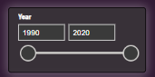

**Activity 1.2: Country**



**Activity 1.3: Continent**

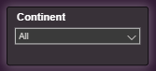

**Activity 1.3: Country Consumption**

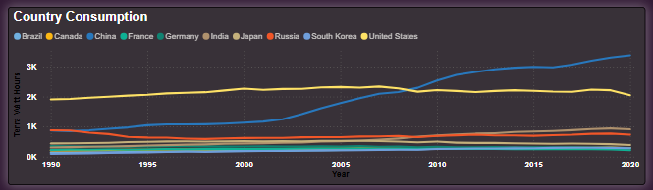

**Activity 1.4: Continent Consumption**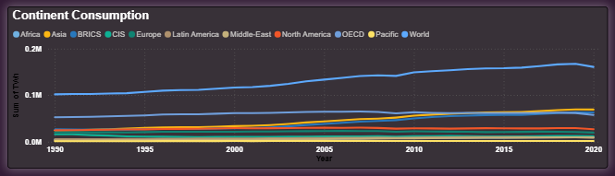

**Activity 1.5: Non-Renewable Sources**

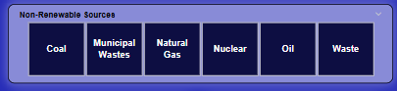

**Activity 1.6: Renewable Sources**

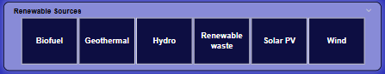

**Activity 1.7:Non-Renewable Sources of Energy**

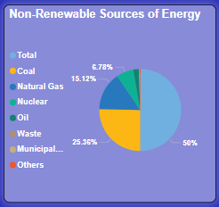

**Activity 1.8: Renewable Sources of Energy**

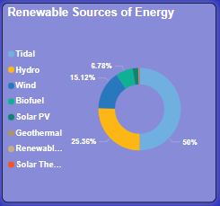

**Activity 1.9: Renewable Energy Generation 1997-2017**

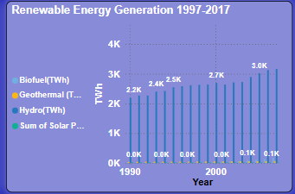

**Activity 1.10: Country**

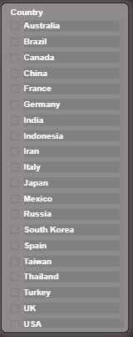

**Activity 1.11: Sum of Total(TWh) by Country** 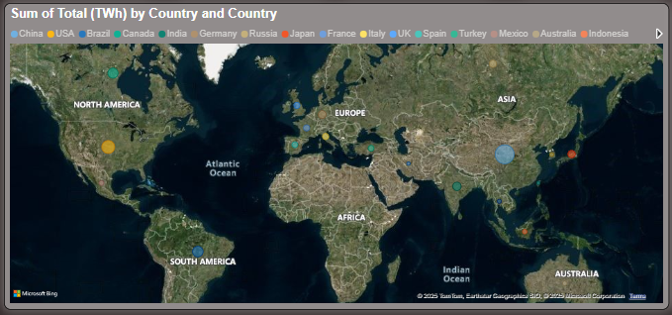

**Activity 1.12: Consumption – OECD, BRICS, CIS**

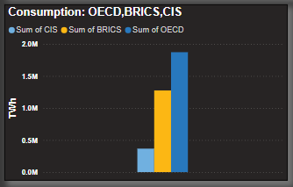

**Activity 1.13: Energy Consumed – Africa**

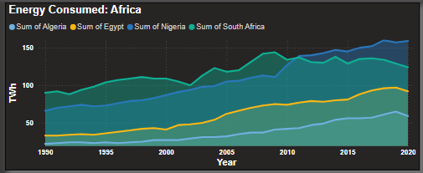

**Milestone 4: Dashboard**

A dashboard is a graphical user interface (GUI) that displays information and data in an organized, easy-to-read format. Dashboards are often used to provide real-time monitoring and analysis of data, and are typically designed for a specific purpose or use case.

**Activity 1: Responsive and Design of Dashboard**

The responsiveness and design of a dashboard for Social Pulse Illuminating the Digital Footprint  Unveiling Social Media Engagement Is crucial to ensure that the information is easily understandable and actionable.The goal is to create a dashboard that is user-friendly, interactive, and data-driven, providing actionable insights to improve the performance and efficiency of Social Pulse Illuminating the Digital Footprint  Unveiling Social Media Engagement.

**Dashboard 1:**

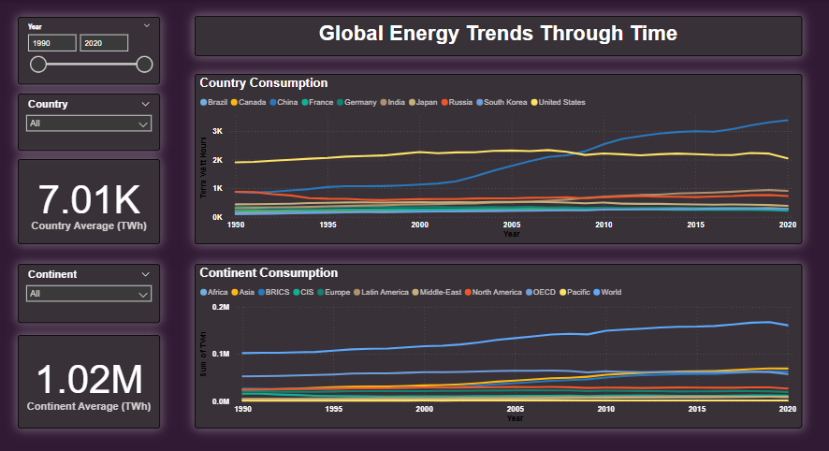

**Dashboard 1:**

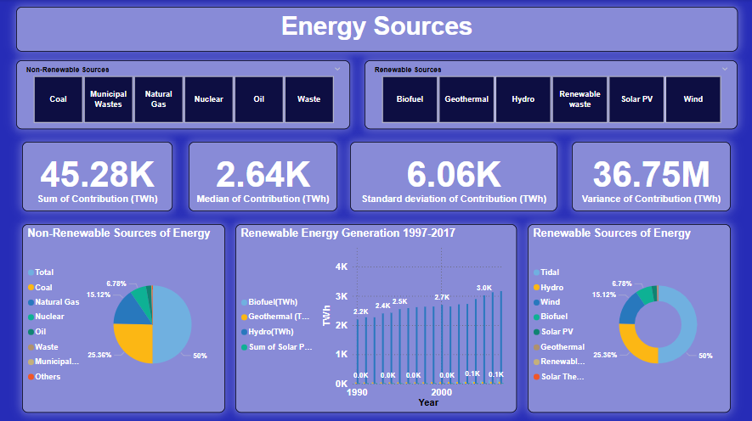

**Dashboard 3:**

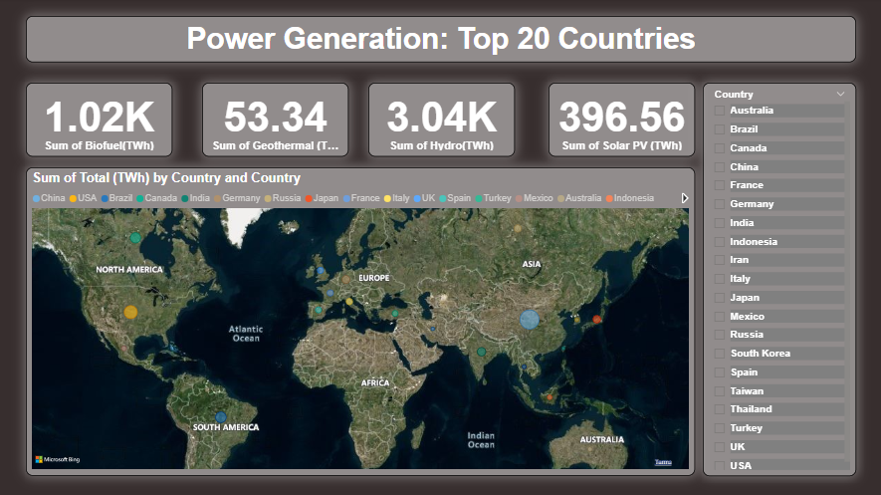

**Milestone 5: Report**

A data report is a way of presenting data and analysis in a narrative format, with the goal of making the information more engaging and easier to understand. Data Report can be told using a variety of mediums, presentations, interactive visualizations, and videos.

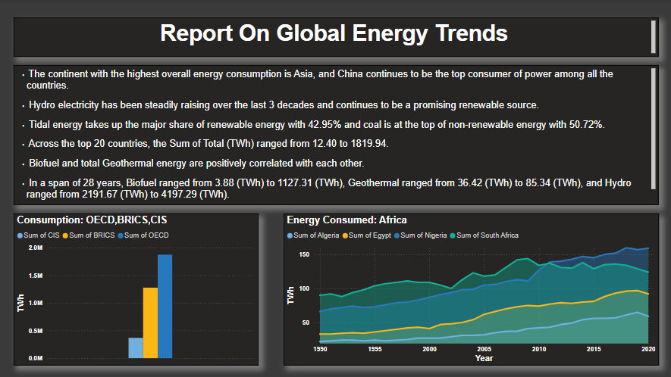

**Milestone 5: Performance Testing**

Performance testing is a crucial aspect of software development aimed at evaluating the speed, responsiveness, stability, and scalability of an application under various workload conditions. It involves simulating real-world usage scenarios to assess how the system behaves and performs under stress, peak loads, or normal conditions.

**Activity 1: Utilization of Data Filters**

The utilization of data filters plays a pivotal role in streamlining information processing and analysis across various domains. By selectively extracting or excluding specific data points based on predefined criteria, filters enable efficient data management and enhance decision-making processes.

Top N Filer on Sum of Biofuel by Country Bar Chart (visual Filter)

Top N Filer on Page

**Activity 2: No of Visualizations/ Graphs**

* 1. Sum of Biofuel(TWH) by Country
  2. Sum of Total(TWH) by country
  3. Renewable Energy Generation 1997-2017
  4. Country Consumption
  5. Continent Consumption
  6. Non-Renewable Sources of Energy
  7. Renewable Sources of Energy
  8. Renewable Energy Generation 1997-2017
  9. Energy Consumed – Africa

**Milestone 8: Project Demonstration & Documentation**

Below mentioned deliverables to be submitted along with other deliverables

**Activity 1:Record explanation Video for project end to end solution**

Creating a record explanation video for a project's end-to-end solution is crucial for ensuring clarity and transparency in its implementation. This video serves as a comprehensive guide, detailing every aspect of the project from inception to completion.

**Activity 2: Project Documentation-Step by step project development procedure**

Create document as per the template provided